Anna Long
Women in STEM: A Comparative Analysis
I chose to research women in STEM (Science, Technology, Engineering, Mathematics) for my trip to France. I wanted to know if women are encouraged to pursue particular areas of study through social media, family, peers, or teachers and if there’s a difference in America vs France. I am interested in the sciences and math and I was always encouraged by my parents and teachers to continue this interest. Recently, I’ve noticed advertisements intended to get girls interested in STEM careers. These advertisements didn’t have an effect on me because I had already decided what I want to do with my life, but it made me wonder if they actually have an impact on girls and if that same type of encouragement is present in France. I’m aware that in the United States it has been a struggle to get women into scientific fields of study since the stereotype that women are to be at home doing the cleaning and taking care of the kids. However, I wasn’t sure if the same type of problem is present in other countries such as France, or if a solution is being approached the same way. In order to fulfill my curiosity, I made surveys for students, took note of every poster or advertisement I saw, and researched statistics of women in STEM for both America and France.
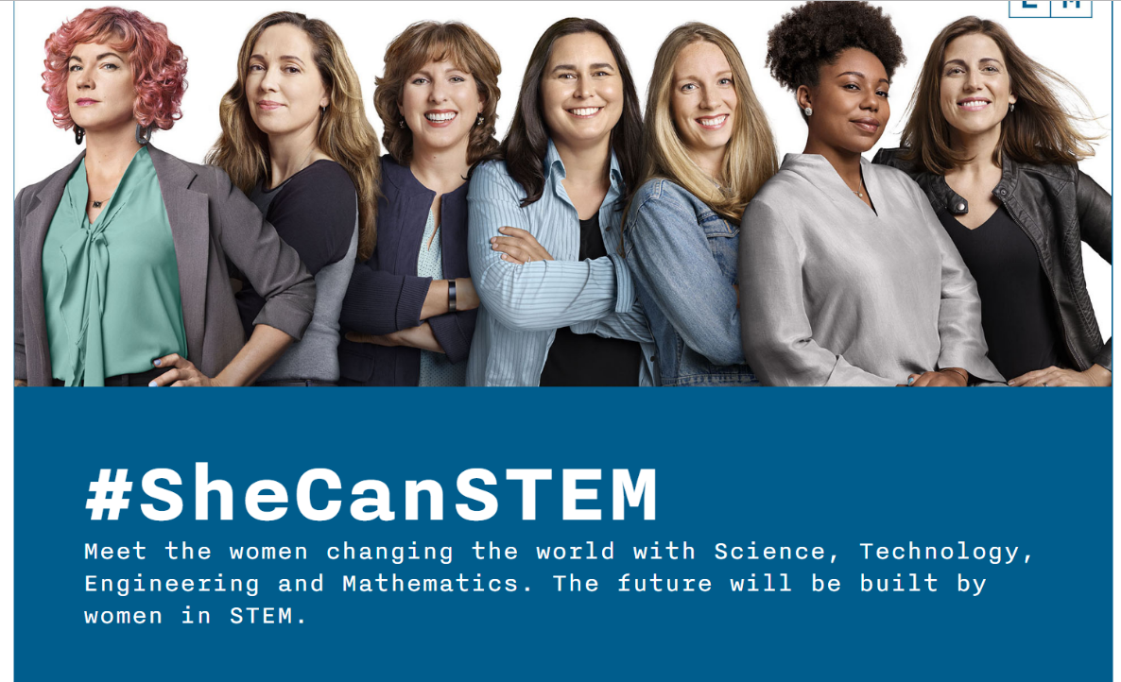
The national ACT test has students report interest in certain fields and then releases a report with that data combined with success on the test. The data from 2017 is given through the chart on the right and shows that male students interested in STEM perform the best on the STEM portions of the ACT. Male students not interested in STEM perform equally to or better than female students interested in STEM on the STEM portions of the ACT. Clearly there is a bias happening somewhere in the system to cause the female students to have such different scores on this test. There is no biological reason for women to perform worse on tests like these. This could even be a cause of discouragement to young women when they see that their male counterparts obtain higher scores.
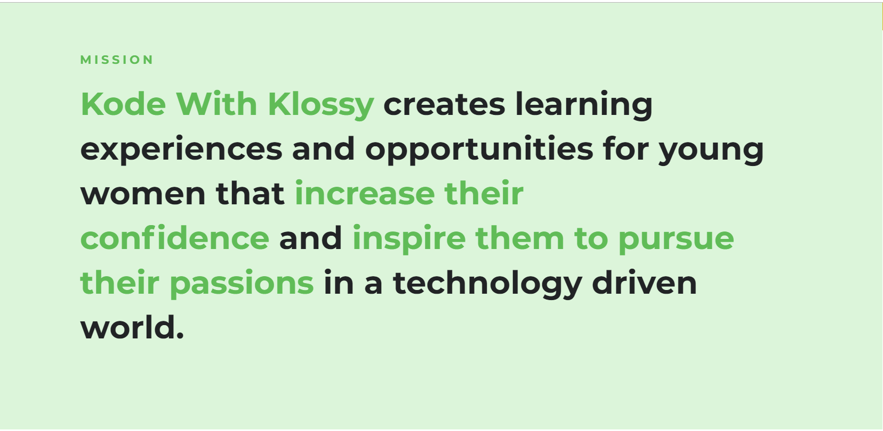
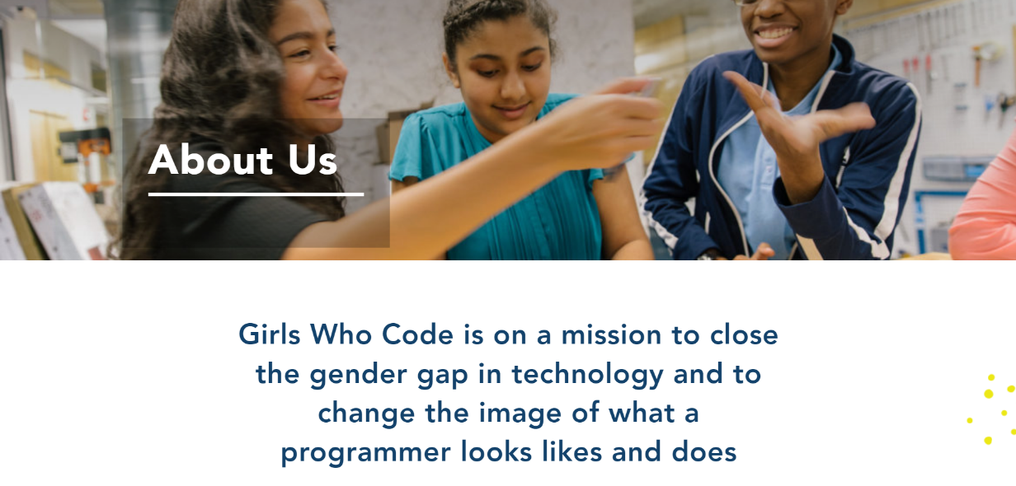
I have taken note of all the forms of advertisements that I’ve seen that are meant to encourage young women into STEM fields of study. Through social media I became aware of “She Can STEM” and “Kode with Klossy” and through posters in my school I learned about “Girls Who Code.” “She Can STEM” is a program that promotes sucessful women in STEM careers to motivate young girls into pursuing their dreams. I have seen multiple sponsored ads for She Can STEM through Instagram, Youtube, and TV commerials. She Can STEM partners with Girls Who Code, Kode with Klossy, and other similar organizations to offer classes or mentors in science or math. There are plenty of great women mentors that are willing to help kids find the right path for them and to teach skills on how to ignore the nay sayers. It’s designed to be as accessable as possible. There are online resources such as livestream events and programs to teach girls about the STEM world from home. The Girls Who Code events are free and public across the nation. Programs like these are gaining popularity nation-wide in order to encourage and teach women about the STEM studies.
I created a survey for students at my high school to take in order for me to gain an understanding of what is motivating young women into STEM careers. The survey is:
Grade: 10 11 12
Gender: Male Female Rather not say
Are you interested in pursuing a STEM career? Yes No Undecided
(if no, then you may stop here)
Please rank the top three factors that have influenced you. 1 being the most influential.
Family___, Teachers___, Peers___, Social Media___, Cinema___, Personal Experience___, Other and specify_________________________________________________________
Through this, I learned that roughly 70% of the girls interested in STEM were motivated by personal experience. This shows the value of making STEM programs accessible nationwide. I then translated the same survey into French to give to the students at Lycee Delambre. Here the survey in French for reference:
Classe: Seconde Premèire Terminale
Sexe: Homme Femme ne veux pas dire
Est-ce que vous vous intéressez à poursuivre des études de STIM? Oui Non Indécis
(Si no, vous pouvez arrêter ici)
S’il vous plaît choississez les trois principaux facteurs qui vous influencent.
Famille___, Profs___, Pairs___, Média Sociaux___, Cinéma___, Expérience Personelle___, Autre et spécifiez_________________________________________________________
Out of the French students only about 60% of girls interested in STEM reported personal experience as the cause, they were more influenced by their family (72%). This shows that it could be easier for families to get stuck in cycles of behavior; however, when a woman in a family finally pursues a career in STEM, it would motivate the future generations into following a similar path.
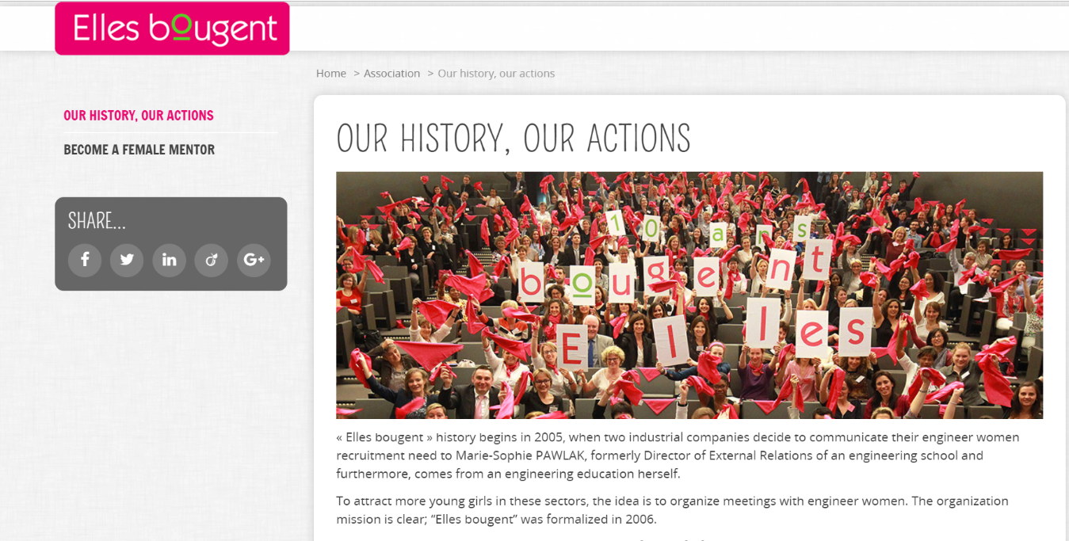
A program that I heard about in France is called “Elles Bougent” and from what I gathered I beilive it to be very similar to “She Can STEM.” Industrial companies joined up because they were lacking female staff. The goal of “Elles Bougent” is to give women access to events and mentors as well as providing vocational training. While this is a very similar approach to the problem, it was much more discreet than the programs I saw in the United States. I never saw posters for this group nor advertisements. I heard about it through a French girl who was a past fellow, so perhaps I wasn’t in France long enough to be as greatly exposed to advertisements for programs like this.
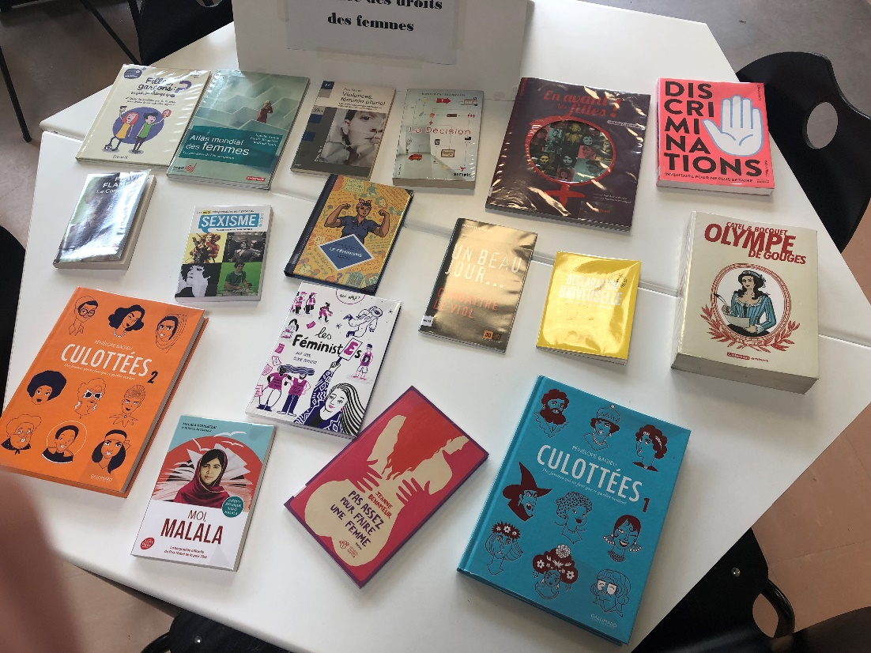
While talking with my host families, I learned that they completely agree with the thought that there aren’t enough women in STEM careers. Socially, this gender gap is the same in France and America. Though, I didn’t see the school trying to decrease the difference. There were plenty of posters supporting the sciences, just not specifically for women. Here is one poster that was on a bulletin in the school hallway that is encouraging students to continue studies in engineering. There is nothing that specifically targets women and the main student in the photograph is visibly male. As well, there was a lot about feminism and empowering young women, just not in the STEM fields specifically. Below is a picture of a book display that was in the school’s library. This section was specifically for recommended books that empower women. However, there wasn’t one book about women pursuing an education or career in a STEM field. With feminism in France being so widespread and accepted, I expected there to be more specifically for those interested in science, technology, engineering, or math.
Overall, I believe that France and America are facing a similar problem with a lack of women with STEM jobs. The United States school system and social media seem like the biggest factors that are working to combat this problem in America. While the issue of feminism is more taboo especially in Oklahoma, it seems easier to address empowering women specifically for STEM fields of study. In France, they seem to be focusing on more of the larger ideas such as feminism in general or the overall need for more people in STEM careers. The average person in both countries seem to be aware of this issue whether they care about it or not, or if they are doing anything to combat it or not. There are also programs available to students, specifically girls, to increase motivation and education. A very similar problem is present across the world, and I believe that there’s the potential for women to be in equal quantity and quality as men in the STEM workforce.

