A Comparison of Technological Use

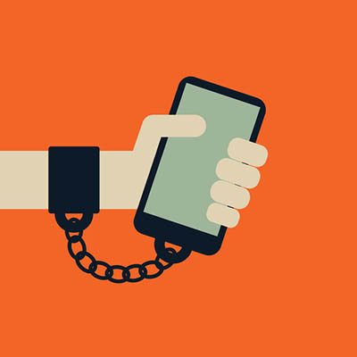
Peter Berryman
Alliance Francaise
2019

If you asked the average 10-year-old kid in a first-world country if he or she had his or her own mobile phone, the answer would most likely be yes. In fact, over 60% of children living in a first-world country between the ages of 8-10 have their own cell phone. The speed at which Apple, Samsung, and other big technology brands have created handheld smart devices and the role they’ve come to play in society is shocking. On June 29, 2007, Steve Jobs presented a revolutionary product to a board of executives at the MacWorld Conventions in San Francisco: the iPhone. Ten years later, in 2017, over 83% of mobile users would have an iPhone in their pocket. The leaps and bounds technology has taken over the last decade does call for excitement. However, it’s crucial that we find a balance between the technological world and the world around us. After having spent two weeks collecting data in France, and many more in The United States, I would like to present a comparison between the two countries on account of their “balance.” In France, like most European countries, the iPhone is seen mainly as a luxury item. The high prices of Apple products repel the bulk of mobile users to other companies such as Samsung or Sony. However, in America, Apple products will only vary about $100 from any other top company’s devices. With this said, The American Youth are much more likely to be surrounded by multiple devices throughout their homes. These social differences between France and the United States produced differing data points in terms of technological use. This report covers the major uses of, and the effects cell phones have on their users, as well as the awareness each country has in terms of keeping “balance.”
The usage of cell phones and other technological devices among youth was fairly similar between the two countries. Among the youth, the two main uses of technology in both France and the United States are social media and surfing the web. The two most popular social media networks were Snapchat (52.08% of people say Snapchat is what they use most) and Instagram (41.60% of people say Instagram is what they use most). Both of these applications offer the user a mode of connection to other users across the globe. One could text or share pictures with a friend down the street or with someone thousands of miles away. This wide network and capability, as well as the notion of “liking” your friends' posts and having your posts “liked” by others, attracts the bulk of its users. In the United States, the average teenager between the ages of 14 and 19 uses his/her phone three to four hours per day (38.54% of people said they use their phone for this time per day in the US), followed by four to five hours per day (20.83% of people said they use their phone for this time per day in the US). In France; however, the average teenager between the ages of 14 and 19 uses his/her phone two to 3 hours per day (72.54% of people said they use their phone for this time per day in France), followed by one to two hours per day( 24.98% of people said they use their phone for this time per day in France). The differing quantities of hourly usage between The United States and France could be a result of the much stricter regulations of phone-usage in French high schools compared to those in The United States. In France, if a phone is seen during a class, the student is immediately punished and the phone is confiscated; however, in The United States, the majority of high schools don’t have as strict of regulations. Nevertheless, social media was found to attract the majority of mobile users between the ages of 14 to 19 in both The United States and France. However, the societies surrounding the youth caused the hourly usage amongst teenagers to fluctuate between the two.
Secondly, questions were asked in regards to addiction. Especially as a teenager, addiction is very hard to measure. With a subject like technological use, each has his or her own opinion over what is a fair amount of time per day. For most teens, this decision comes through the choices of their parents. Some people might be completely against the usage of technology and therefore forbid their presence in a household. On the other hand, some parents show little to no concern over their child’s usage of technology. To analyze this, I chose to use something called “Digital Citizenship.” According to The TeachThought Magazine originally published in 2013, Digital Citizenship is defined by “the habits, actions, and consumption patterns that impact the ecology of digital content and communities.” This notion is meant to make teens independent of their parents and have the want to monitor their own use of technology as a citizen of a country would monitor his/her own rights. This term also implies that it is a duty to find the “balance” of technology in daily life. In order to utilize the aspects of digital citizenship in my research, I took time to explain its values in my questions. For example, questions would be asked such as “If you lived alone and had no responsibilities outside of leisure but still used your phone in equal time frames as you do now, would you consider yourself to be addicted to your phone?” In The United States, 59.80% of teenagers between the ages of 14 and 19 said they were not addicted to their cell phone, while in France, over 80% of the same age group said they were not addicted. Through forcing the survey-takers to take responsibility for their own use of technology, I hoped to generate more honest results.
In conclusion, both the benefits and disadvantages technology has given society throughout the past decade stand as only the beginning of what is to come. In the next decade, the standards for technology will be completely different from the ones that exist today. After having completed this comparison of technology between The United States and France, I would like to raise awareness and support for finding a “balance.” The objective of this survey was to collect information from the mass amount of teenagers living in The United States and France in regards to the role technology plays in their lives. After having analyzed the data collected in the two countries, I would like to take steps in a different direction. If Steve Jobs released the iPhone in 2007, where will the world be in 2027? 2057? With newfound technology, the human race will be able to explore unknown parts of the universe and cure disease. However, it’s mandatory that we take time to spend with our families, get outside and grow, and enjoy life as it is.

“Definition Of Digital Citizenship.” TeachThought, 17 Dec. 2018, www.teachthought.com/the-future-of-learning/the-definition-of-digital-citzenship/.

